Loop of wire ~140mA RMS , frequency 10kHz
Battery pack- 7.2V- do not connect directly to motor
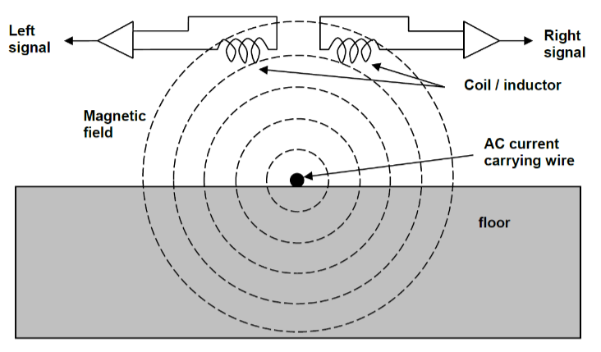
ferrite core Inductor- 330µH

-AC current in wire induces V in coil
- two coils side by side induce voltages of different amplitude based on Faradays law $ε=-N\frac{ΔΦ}{Δt}$.
- Induced emf = number of loops * change in flux over time
- Meaning more emf induced when more coils or more change I think
-interference from motors
-construct analogue circuits to amplify, filter and detect amplitude of signals
- Recommended circuit
- Use to simulate analyse and improve as necessary
- Calc values for parallel resonant circuit, low pass cut off, high pass cut off and amplifier gain- using capacitor values
- Gain ensure balance bet high sensitivity, low controllability, and low sensitivity, low impact in motor speed
-how to turn sine wave into varying Dc-
- Precision rectifier recommended-
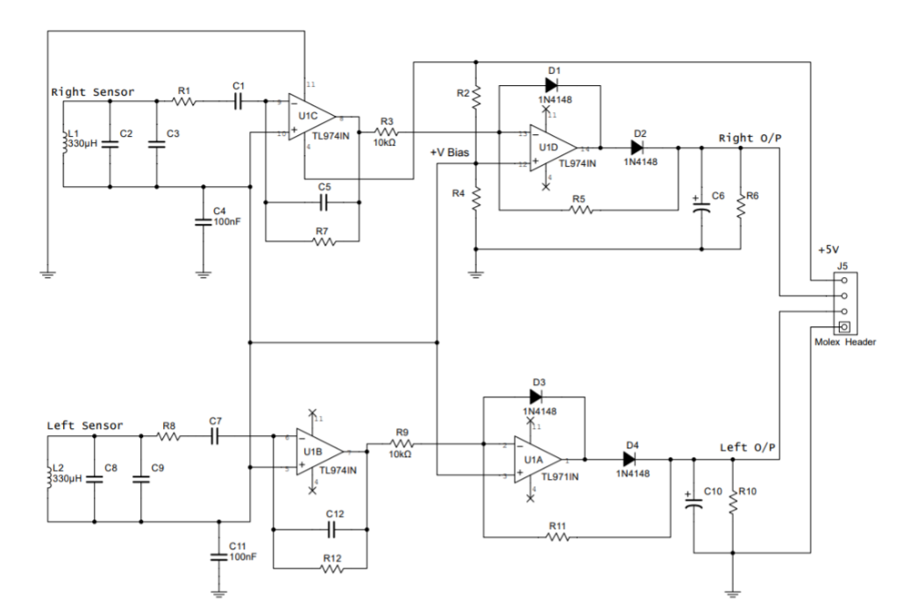
-designed to operate from single dc supply, resistor divider used to set dc operating point
- Suitable operating point voltage and why- Q point
- Common value used as dc operating pt for all further op amps added
To do:
-study components
- Which contribute to what kind of behave
-build circuit with components as suggested(replace LC system w small AC source)
- LT spice
- Project board
transient behaviour to reason for component functionality.
b) Steady-state behaviour for investigating the overall circuit behaviour.
c) AC sweep of the input source to reason for performance of your filters as well
as conditioning filters at the end. Also create a model for relating your DC
outputs based on the AC inputs. This model will be crucial for your
integration.
d) DC sweep to investigate minimum DC operating points (especially when the
battery power is low).
e) Fault diagnostics capability with simulated open and short circuit faults at
different points in the circuit.
f) Can you measure the power consumption of the overall circuit?
-study
- Transient behaviour- to reason for component functionality
- Steady state behaviour- for investigating over circuit behaviour
- AC sweep of input source- to reason for performance of filters and conditioning filters at end- also create model for relating DC outputs based on AC inputs- crucial for integration
- DC sweep to investigate minimum DC operating points- esp when battery power low
- Fault diagnostics w simulated open and short circuit faulst at different points
- Power consumption of overall circuit
-Can it be improved
-design and construct subsystems and think ab integration
-demonstrate how can control motor speed based on position of sensor
-approach designs
- Break into multiple subcircuits and design each until happy w individual operations
- Move towards integ w understanding of overall requirement (should output b limited or should pwm be limited)- investigate as many what ifs as I can (what is cut off f change from xx to yy, what if back emf diode not connected, impact of changing gain of amplifier)

COMPONENTS-
opamp 1 + 2
Opamp is TL974-
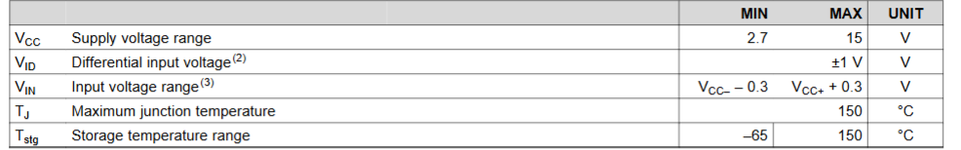
Inverting amplifier $A_{CL}= \frac{V_{out}}{V_{in}}=- \frac{R_{f}}{R_{g}}$- the Rg being the res going in and Rf being feedback resistance only powered from a single supply so needs DC offset to positive input- using resistive pot divider circuit- research eq and think of appropriate V applied to + inp- resistor divider used to set dc operating pt of amplifier

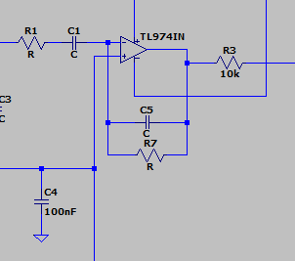
Op amp with resistor and capacitor in series going in and also in the feedback system resistor and capacitor in parallel
- active bandpass filter- w opamp so gain can affect stuff
- the ratios affect the allowed frequencies and stuff
Cut off frequency is -3dB point
-https://www.electronics-tutorials.ws/filter/filter_7.html
-separates a signal at one frequency or a range
- two cut offs- lower frequency and higher frequency
-cut-off of low pass must be higher than cut-off of high pass w difference between -3dB point determining bandwidth

Lower cut off – 3dB is fc1, upper is fc2
$$f_{C1}=\frac{1}{2πC_{5}R_{7}}$$
$$f_{C2}=\frac{1}{2πC_{1}R_{1}}$$
probably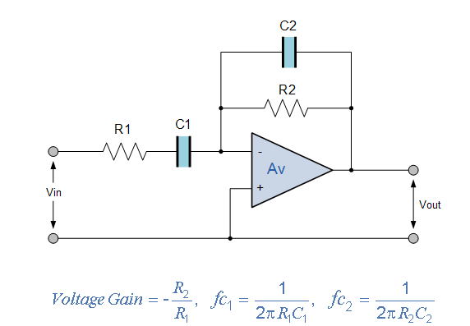
Low pass-
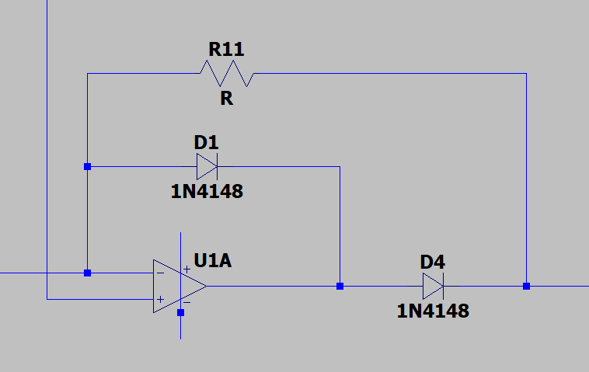
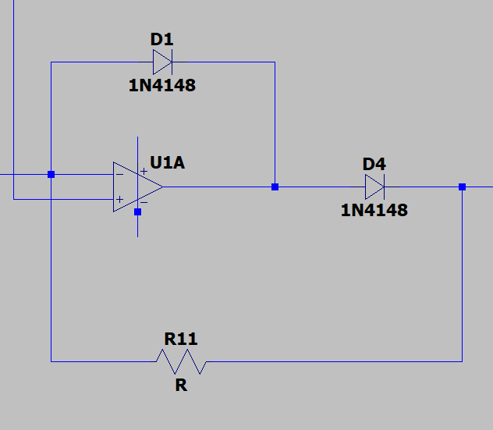
Other part- Half wave precision rectifier
- Input sine output half sine pulses w +ve only
- Positive V D2 closes –ve feedback loop
- Resistance values affect slope of output voltage
- 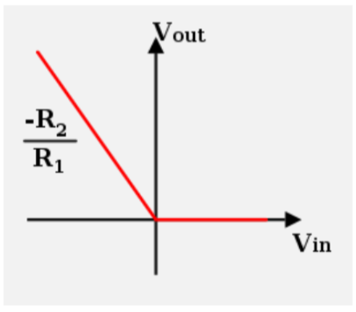

-Diode across opamp with diode after and resistor across diode
https://www.ti.com/lit/an/sboa227b/sboa227b.pdf?ts=1770695111295#:~:text=Precision%20half%2Dwave%20rectifiers%20are,at%20frequencies%20up%20to%2050kHz.
Precision half-wave rectifiers are commonly used with other op amp circuits such as a peak-detector or bandwidth limited non-inverting amplifier to produce a DC output voltage.
-minimise noise by selecting low value resistors
-set output range based on linear swing
https://www.electronics-tutorials.ws/diode/diode_5.html
- AC to DC- passing either negative or positive half cycle of waveform + blocking the other

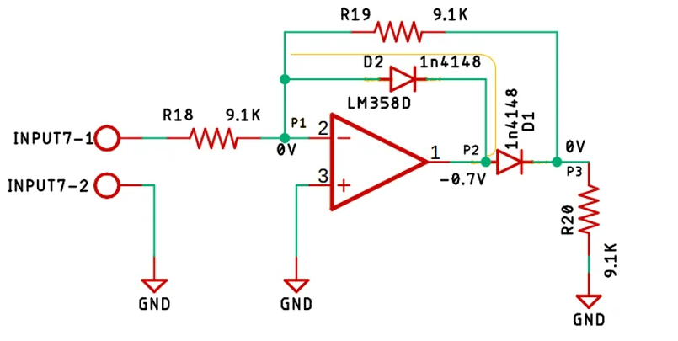
-https://circuitdigest.com/electronic-circuits/half-wave-and-full-wave-precision-rectifier-circuit-using-op-amp
-uses op amp to compensate for V drop across diode- not losing 0.7V voltage drop across
- additionally, can have gain at output
- zero output when ac negative
- add load resistor- practically formed voltage divider w 2 9.1k and one r20
- d2 conduct if positive half of sinusoidal is an input. Yellow line completed and op amp acting as inverting amplifier
-point 1 virtual ground, no I thru R19, output Point 2, V is -0.7V
-0V whenever +ve halfcycle to opamp
- negative half of AC- D2 is reverse biased, open circuit
- I thru R22, virtual grnd pt1
-diode conduct and get compensated output at p3
-output V will be -Vin/R2= Vout/R1, Vout= -R2/R1*Vin
- full wave rectifier better
-diodes allow for inp sine wave and out put half sine pulses w positive only
-+ve inpt D2 conducts and closes –ve feedback loop of op amp
Capacitor afterwards smooths

Resonator circuit- LC
-Inductive coil with capacitor, induced V from varying mag field causes and induced current to flow which charges and discharges at the resonant frequency

$f=\frac{1}{2π\sqrt{LC}}$-
we want this
approximately the same as the 10kHz signal in the floor- with the 330mH inductor can work out the capacitance- need it for the parallel capacitors
Construct analogue signal; to amplify filter and detect amplitude of induced signals in each sensor
Calc appropriate values for low pass cut off (c5), high pass cut off (c1) and amplifier gain (R7)- determine gain suitably for balance between high sense (and low controlability) and low sensitivity (low impact onmotor speed)- R1 is 1k
Shares same power supply as the PIC

https://www.eleccircuit.com/full-wave-rectifier-with-an-op-amp-ic/
STUDY-
How do i want it to behave-
Works by inductively sensing a wire loop, carrying an
AC current, which is buried beneath the flooring- the ac current will induce a magnetic field- two coils side by side and compare amplitude of induced voltage and deduce which way to steer a vehicle to follow the track- depends on mag and direction of mag field-weak signal if field perpend to coil axis
and =BA
𝑒 is the induced voltage.
𝑁 is the total number of turns of the loop.
𝜙 is the (Magnetic flux).
𝐵 is the magnetic field.
𝐴 is the area of the loop.
𝑡 is the time
- If there is more AC it will induce a magnentic field withmore flux
- -if a wire is going to the left, then the left sensor will have more flux in it i believe
- Therefore it wants to follow where more induced voltage in the inductor?

A) transient behaviour to reason for component functionality.
-transient state- not steady state- Damien stuff I think
-transient behaviour is behaviour at change of input before it settles to steady state
-initial surge in
- this is to do with the inductor and capacitor
- the RC time of the capacitor resistor combo – RC time

b) Steady-state behaviour for investigating the overall circuit behaviour.
-also damien stuff I think
-unsure about this
-obviously whne it settles but not sure how to look at
-it oscillates?
c) AC sweep of the input source to reason for performance of your filters as well
as conditioning filters at the end. Also create a model for relating your DC
outputs based on the AC inputs. This model will be crucial for your
integration.
d) DC sweep to investigate minimum DC operating points (especially when the
battery power is low).
e) Fault diagnostics capability with simulated open and short circuit faults at
different points in the circuit.
f) Can you measure the power consumption of the overall circuit?- probably

